# Project Design Phase-I Solution Architecture

|  |  |
| --- | --- |
| Date | 15.10.2022 |
| Team ID | PNT2022TMID09849 |
| Project Name | Gas Leakage Monitoring and Alerting System using IoT |
| Maximum Marks | 4 Marks |

**Solution Architecture:**

* Safety for all must be insured in today’s world and it is necessary that efficient and proactive safety systems should be implemented in public places and households.
* The main objective of this IOT based work is designing micro-controller based toxic gas detecting and alerting system.
* The hazardous gases like LPG and propane were sensed.
* If the hazardous gases exceed the normal level then an alarm is triggered immediately at the incident place.
* An alert message (i.e. Push Notification) is sent to the authorized person through the INTERNET with the help of used **ESP8266 module** incorporating **IoT device.**
* The advantage of this IOT based automated detection and alerting system over the manual method is that it provide **real time response** and accurate detection of an emergency and in turn leading faster control over the critical situation.
* Hardware Required for IOT based Project are :

1) Arduino Uno

2) ESP8266 Wifi Module

3) Jumper Wires

4) LED

5) Buzzer

* Steps for Creating IOT based Project:

1)Hardware Connection.

2)Configuring Iota Cloud foruploading Sensor Values.

3)Make changes to Code & Upload.

4)Posting to Pushbullet via Iot cloud.

5)Getting push Notification on Android.

# Example - Solution Architecture Diagram:

s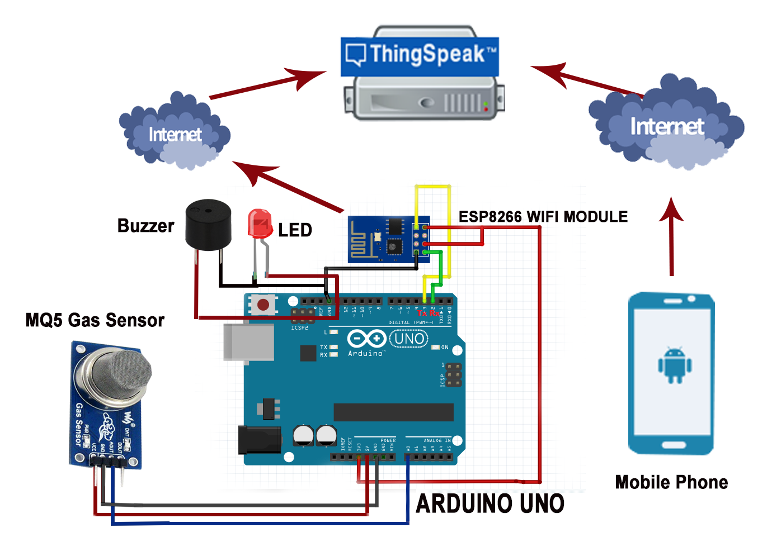

IoT Device